Location |  |  |  | Date
Shift _____________ |  | Publishers ____________/______________
 | English |  | Spanish |  |  | Total
Bibles
Books
Magazines
Brochures/Tracts
Electronic
Videos Shown
Quality Conversations |  |  |  |  | 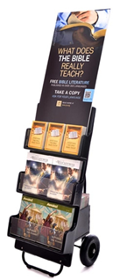
Study Requests
Location |  |  |  | Date
Shift _____________ |  | Publishers ____________/______________
 | English |  | Spanish |  |  | Total
Bibles
Books
Magazines
Brochures/Tracts
Electronic
Videos Shown
Quality Conversations
Study Requests
Location |  |  |  | Date
Shift _____________ |  | Publishers ____________/______________
 | English |  | Spanish |  |  | Total
Bibles
Books
Magazines
Brochures/Tracts
Electronic
Videos Shown
Quality Conversations
Study Requests
Location |  |  |  | Date
Shift _____________ |  | Publishers ____________/______________
 | English |  | Spanish |  |  | Total
Bibles
Books
Magazines
Brochures/Tracts
Electronic
Videos Shown
Quality Conversations
Study Requests
Location |  |  |  | Date
Shift _____________ |  | Publishers ____________/______________
 | English |  | Spanish |  |  | Total
Bibles
Books
Magazines
Brochures/Tracts
Electronic
Videos Shown
Quality Conversations
Study Requests
Location |  |  |  | Date
Shift _____________ |  | Publishers ____________/______________
 | English |  | Spanish |  |  | Total
Bibles
Books
Magazines
Brochures/Tracts
Electronic
Videos Shown
Quality Conversations
Study Requests

